BUS TICKETING SYSTEM

__________

A Project Presented to
Mr. Joseph M. Pequit of the College of Computing and Information Sciences
BOHOL ISLAND STATE UNIVERSITY
Balilihan Campus
Magsija, Balilihan, Bohol

__________

In Partial Fulfillment
of the Requirements for the Subject
CC 221 Database Management System 2

Erikson J. Apolona
Lawrence F. Fuerzas
James Patrick P. Estomo
Mark James R. Patac
Krizziana A. Paat
Jonna G. Sumabong

May 2025
SCOPE AND LIMATIONS

This study focused on the development of a bus ticketing system designed to streamline the process of ticket reservation, passenger management, and trip scheduling for a bus transportation company. The system allowed passengers to view available trips, reserve seats, and make payments online. It also enabled administrators to manage bus schedules, monitor seat availability, and generate reports related to sales and passenger data. The system was developed as a web-based application to enhance accessibility for both passengers and staff.
However, the scope of the system was limited to handling ticketing operations for a single bus company and did not support inter-company ticketing or coordination with terminal authorities. The online features of the system, such as seat reservation and payment processing, required a reliable internet connection to function properly. Furthermore, integration with third-party payment gateways was limited to select providers. The system was not designed for offline use or mobile applications and was optimized for use on modern web browsers and devices only

OBJECTIVES

The main objective of this study is to develop a Bus Ticketing System that aims to automate and streamline the process of ticket booking, schedule management, and passenger information handling. This system is designed to enhance the efficiency of bus operations and provide convenience to both administrators and commuters.
Specific Objectives
Specifically, this study aims to:
1. Develop a mobile-accessible platform that allows passengers to conveniently book bus tickets and view schedules using their smartphones or mobile devices.
2. To allow administrators to manage bus schedules, routes, fares, and seat availability efficiently.
3. To automate the ticket issuance process to minimize manual errors and reduce waiting time.
4. To maintain a database that stores passenger details, booking history, and payment records for easy access and management.
5. To generate reports on ticket sales, peak hours, and revenue for decision-making and planning.

ENTITY RELATIONSHIP DIAGRAM

ENTITIES AND ATTRIBUTES
Booking Table
Attributes | Primary Keys | Foreign Keys
Booking_id
Bus_id
date
Depart_time
Seats_booked

Bus Table
Attributes | Primary Keys | Foreign Keys
bus_id
Route_id
busname
Bus_capacity
driver_name

Driver Table
Attributes | Primary Keys | Foreign Keys
id
name
age
address
contact

Conduktor Table
Attributes | Primary Keys | Foreign Keys
id
c_name
c_age
c_address
c_contact
Assigned

Favorites Table
Attributes | Primary Keys | Foreign Keys
bustype
destination
status

Passenger Table
Attributes | Primary Keys | Foreign Keys
p_id
p_name
p_contact
p_add
zipcode

UserTable
Attributes | Primary Keys | Foreign Keys
id
name
username
email
password
role

Payment Table
Attributes | Primary Keys | Foreign Keys
payment_id
ticket_id
payment_date
amount
payment_method
payment_status
status

RouteTable
Attributes | Primary Keys | Foreign Keys
Route_id
Depart_time
destination
Terminal
r_id

Ticket Table
Attributes | Primary Keys | Foreign Keys
ticket_id
bus_id
busname
Depart_time
destination
Tickets
date
status
FLOW CHART

DATABASE SCHEMA

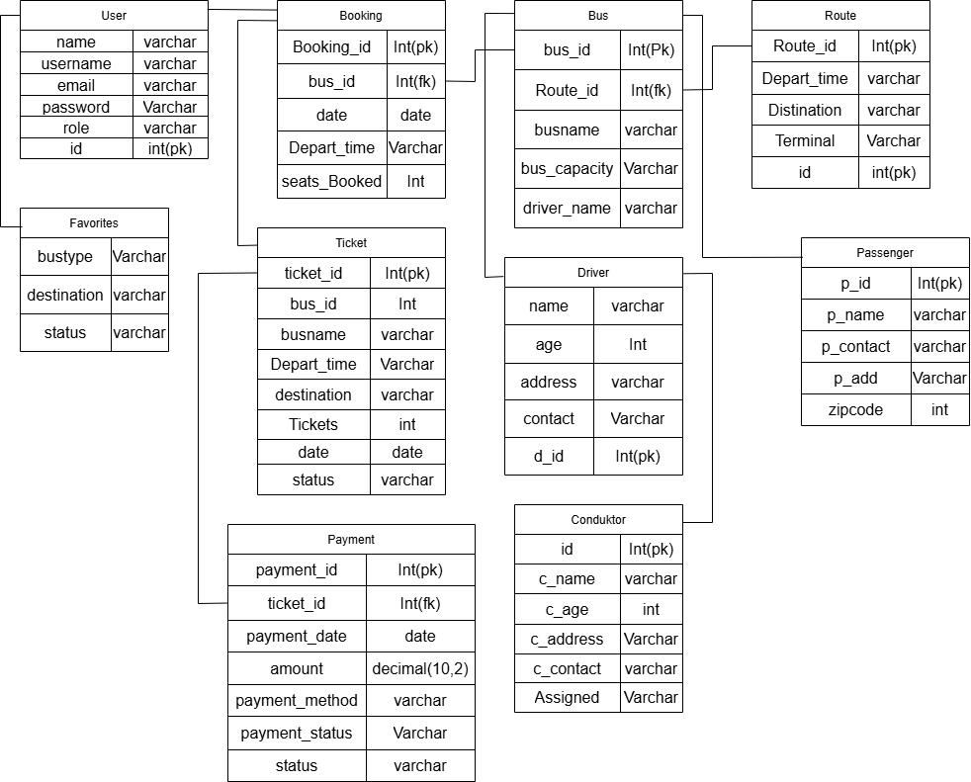

SOURCE CODE
~Limit rag 3 pages.

@include('templates.header')

<style>
.announcement-title {
text-align: center;
margin: 30px 0;
font-size: 2.5rem;
font-weight: 800;
color: #0D7C66;
text-transform: uppercase;
letter-spacing: 2px;
text-shadow: 2px 2px 4px rgba(0, 0, 0, 0.1);
}

.event-list {
margin-top: 30px;
padding: 0 20px;
}

.event-item {
padding: 25px;
border-radius: 15px;
box-shadow: 0 8px 16px rgba(13, 124, 102, 0.1);
margin-bottom: 25px;
transition: all 0.3s ease;
border-left: 5px solid #0D7C66;
background: linear-gradient(to right, #ffffff, #f8f9fa);
margin-left: 40%;
width: 90%;
position: relative;
overflow: hidden;
}

.event-item:hover {
transform: translateY(-5px);
box-shadow: 0 12px 20px rgba(13, 124, 102, 0.15);
}
.event-date {
background: linear-gradient(135deg, #0D7C66, #0a5d4d);
color: white;
padding: 15px;
border-radius: 10px;
font-size: 1.1rem;
box-shadow: 0 4px 8px rgba(13, 124, 102, 0.2);
}

.event-date .number {
font-size: 1.5rem;
font-weight: bold;
margin-bottom: 5px;
text-shadow: 1px 1px 2px rgba(0, 0, 0, 0.2);
}

.event-title {
font-weight: bold;
font-size: 1.6rem;
color: #2c3e50;
margin-bottom: 15px;
padding-bottom: 10px;
border-bottom: 2px solid #eee;
}

.event-location {
color: #566573;
font-size: 1.1rem;
margin: 10px 0;
padding: 8px 0;
}

.badge {
padding: 8px 15px;
font-size: 0.9rem;
font-weight: 500;
letter-spacing: 0.5px;
border-radius: 20px;
margin-top: 10px;
}

.bg-danger {
background-color: #e74c3c !important;
}

.bg-info {
background-color: #3498db !important;
}

.immunization-details {
background-color: #f8f9fa;
padding: 12px 15px;
border-radius: 8px;
margin: 15px 0;
border: 1px solid #e9ecef;
}

.text-muted {
color: #626567 !important;
font-size: 1rem;
}

.mt-2 {
margin-top: 15px !important;
}

marquee {
font-size: 30px;
margin: 20px 0;
}
.scroll{
background: linear-gradient(45deg, #0D7C66, #0a5d4d);
}
.marquee-text {

color: white;
padding: 10px 20px;
border-radius: 25px;
box-shadow: 0 4px 6px rgba(13, 124, 102, 0.1);
display: inline-block;
font-weight: 600;
letter-spacing: 1px;
}

/* QR Code Styling */
.qr-container {
position: fixed;
left: 300px;
top: 55%;
transform: translateY(-50%);
z-index: 1000;
background-color: white;
padding: 10px;
border-radius: 12px;
box-shadow: 0 8px 16px rgba(0, 0, 0, 0.1);
transition: transform 0.3s ease;

}

.qr-container:hover {
transform: translateY(-52%) scale(1.05);
}

.qr-container img {
border-radius: 8px !important;
width: 500px !important; /* Change this value to whatever size you want */
height: 500px !important; /* Keep same as width */
object-fit: contain !important;
}

/* Additional Enhancements */
strong {
color: #0D7C66;
font-weight: 600;
}

p {
line-height: 1.6;
color: #444;
}
/* Update QR container style to include padding for text */
.qr-container {
position: fixed;
left: 300px;
top: 65%;
transform: translateY(-50%);
z-index: 1000;
background-color: white;
padding: 15px;
border-radius: 12px;
box-shadow: 0 8px 16px rgba(0, 0, 0, 0.1);
transition: transform 0.3s ease;
text-align: center;
}

.qr-container:hover {
transform: translateY(-52%) scale(1.05);
}

/* Style for the payment text inside QR container */
.qr-payment-text {
background: linear-gradient(45deg, #0D7C66, #0a5d4d);
color: white;
padding: 8px 12px;
border-radius: 6px;
font-weight: bold;
font-size: 0.85rem;
margin-bottom: 10px;
display: block;
animation: pulse 2s infinite;
}

@keyframes pulse {
0% {
transform: scale(1);
}
50% {
transform: scale(1.02);
}
100% {
transform: scale(1);
}
}
</style>

<div id="layoutSidenav_content">
<main>
<div class="container-fluid px-4">
@if(Auth::user()->user_type == "resident")
@php
$prenatals = App\Models\Prenatal::select('*', 'created_at as sort_date')->get()->toArray();
$immunizes = App\Models\Immunize::select('*', 'created_at as sort_date')->get()->toArray();
$events = App\Models\Event::select('*', 'created_at as sort_date')->get()->toArray();

$allRecordsArray = array_merge($prenatals, $immunizes, $events);
usort($allRecordsArray, function($a, $b) {
return strtotime($b['created_at']) - strtotime($a['created_at']);
});
@endphp

<div class="announcement-title">📢 Announcements</div>

<div class="qr-contain

